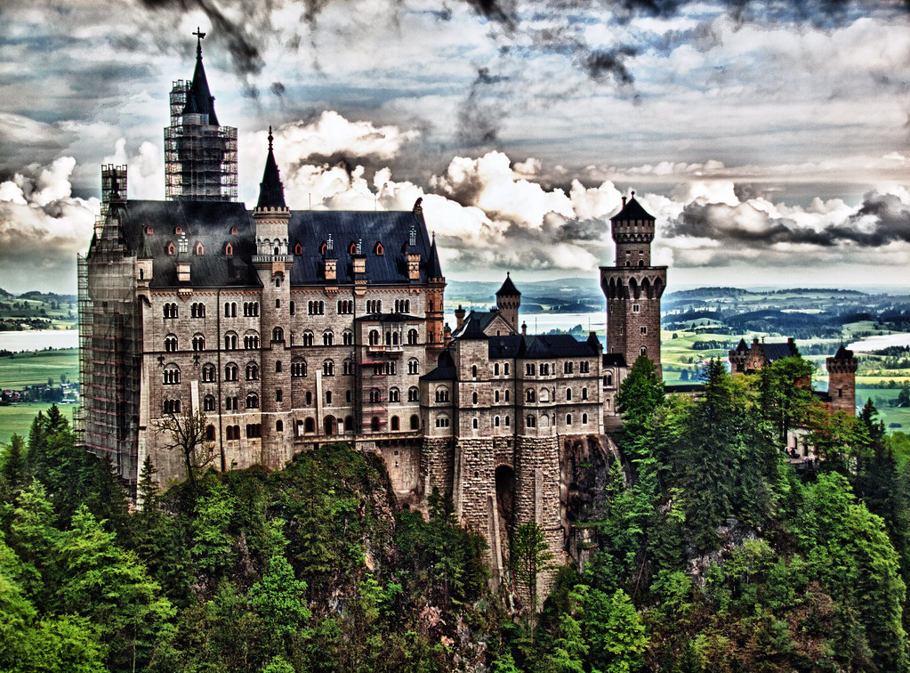

# Neuschwanstein Castle

**Neuschwanstein Castle** ([German](https://en.wikipedia.org/wiki/German_language): *Schloss Neuschwanstein*, pronounced [[ˈʃlɔs nɔʏˈʃvaːnʃtaɪn]](https://en.wikipedia.org/wiki/Help:IPA/Standard_German); [Southern Bavarian](https://en.wikipedia.org/wiki/Southern_Bavarian): *Schloss Neischwanstoa*) is a 19th-century [historicist](https://en.wikipedia.org/wiki/Historicism_(art)) palace on a rugged hill of the foothills of the [Alps](https://en.wikipedia.org/wiki/Alps) in the very south of [Germany](https://en.wikipedia.org/wiki/Germany). It is located in the [Swabia](https://en.wikipedia.org/wiki/Swabia_(Bavaria)) region of [Bavaria](https://en.wikipedia.org/wiki/Bavaria), in the municipality of [Schwangau](https://en.wikipedia.org/wiki/Schwangau" \o "Schwangau), above the incorporated village of [Hohenschwangau](https://en.wikipedia.org/wiki/Hohenschwangau" \o "Hohenschwangau), which is also the location of [Hohenschwangau Castle](https://en.wikipedia.org/wiki/Hohenschwangau_Castle" \o "Hohenschwangau Castle). The closest larger town is [Füssen](https://en.wikipedia.org/wiki/F%C3%BCssen" \o "Füssen). The castle stands above the narrow gorge of the Pöllat stream, east of the [Alpsee](https://en.wikipedia.org/wiki/Alpsee" \o "Alpsee) and [Schwansee](https://en.wikipedia.org/wiki/Schwansee" \o "Schwansee) lakes, close to the mouth of the [Lech](https://en.wikipedia.org/wiki/Lech_(river)) into [Forggensee](https://en.wikipedia.org/wiki/Forggensee" \o "Forggensee).

Despite the main residence of the [Bavarian monarchs](https://en.wikipedia.org/wiki/Bavarian_monarchs) at the time—the [Munich Residenz](https://en.wikipedia.org/wiki/Munich_Residenz)—being one of the most extensive [palace](https://en.wikipedia.org/wiki/Palace) complexes in the world, [King Ludwig II of Bavaria](https://en.wikipedia.org/wiki/King_Ludwig_II_of_Bavaria) felt the need to escape from the constraints he saw himself exposed to in [Munich](https://en.wikipedia.org/wiki/Munich), and commissioned Neuschwanstein Palace on the remote northern edges of the Alps as a retreat but also in honour of composer [Richard Wagner](https://en.wikipedia.org/wiki/Richard_Wagner), whom he greatly admired.

Ludwig chose to pay for the palace out of his personal fortune and by means of extensive borrowing rather than Bavarian public funds. Construction began in 1869 but was never completed. The castle was intended to serve as a private residence for the king but he died in 1886, and it was opened to the public shortly after his death.[[1]](https://en.wikipedia.org/wiki/Neuschwanstein_Castle#cite_note-50million-1) Since then, more than 61 million people have visited Neuschwanstein Castle.[[2]](https://en.wikipedia.org/wiki/Neuschwanstein_Castle#cite_note-premiummarke-2) More than 1.3 million people visit annually, with as many as 6,000 per day in the summer.[[](https://en.wikipedia.org/wiki/Neuschwanstein_Castle#cite_note-internet-3)

**History**

Neuschwanstein embodies both the contemporaneous architectural fashion known as castle Romanticism ([German](https://en.wikipedia.org/wiki/German_language): *Burgenromantik*) and King Ludwig II's enthusiasm for the operas of Richard Wagner. In the 19th century, many castles were constructed or reconstructed, often with significant changes, to make them more picturesque. Palace-building projects similar to Neuschwanstein had been undertaken earlier in several of the German states and included Hohenschwangau Castle, [Lichtenstein Castle](https://en.wikipedia.org/wiki/Lichtenstein_Castle_(W%C3%BCrttemberg)), [Hohenzollern Castle](https://en.wikipedia.org/wiki/Hohenzollern_Castle), and numerous buildings on the [Rhine](https://en.wikipedia.org/wiki/Rhine), such as [Stolzenfels Castle](https://en.wikipedia.org/wiki/Stolzenfels_Castle" \o "Stolzenfels Castle).[[10]](https://en.wikipedia.org/wiki/Neuschwanstein_Castle#cite_note-12) The inspiration for the construction of Neuschwanstein came from two journeys that Ludwig took in 1867: one in May to the reconstructed [Wartburg](https://en.wikipedia.org/wiki/Wartburg) near [Eisenach](https://en.wikipedia.org/wiki/Eisenach),[[11]](https://en.wikipedia.org/wiki/Neuschwanstein_Castle#cite_note-MPB50-13) and another in July to the [Château de Pierrefonds](https://en.wikipedia.org/wiki/Ch%C3%A2teau_de_Pierrefonds), which [Eugène Viollet-le-Duc](https://en.wikipedia.org/wiki/Eug%C3%A8ne_Viollet-le-Duc" \o "Eugène Viollet-le-Duc) was transforming from a ruined castle into a [historicist](https://en.wikipedia.org/wiki/Historicism_(art)) palace.[[12]](https://en.wikipedia.org/wiki/Neuschwanstein_Castle#cite_note-MPB51-14)[[nb 3]](https://en.wikipedia.org/wiki/Neuschwanstein_Castle#cite_note-15)

Ludwig believed both buildings represented a [Romanticist](https://en.wikipedia.org/wiki/Romanticist) interpretation of the Middle Ages, as well as the musical mythology of his friend Wagner, whose operas *[Tannhäuser](https://en.wikipedia.org/wiki/Tannh%C3%A4user_(opera)" \o "Tannhäuser (opera))* and *[Lohengrin](https://en.wikipedia.org/wiki/Lohengrin_(opera)" \o "Lohengrin (opera))* had made a lasting impression on him.[[13]](https://en.wikipedia.org/wiki/Neuschwanstein_Castle#cite_note-AFSN197-16) In February 1868, Ludwig's grandfather, King [Ludwig I](https://en.wikipedia.org/wiki/Ludwig_I), died, freeing the considerable sums that were previously spent on the abdicated King's [appanage](https://en.wikipedia.org/wiki/Appanage).[[8]](https://en.wikipedia.org/wiki/Neuschwanstein_Castle#cite_note-AFSN110-10)[[nb 4]](https://en.wikipedia.org/wiki/Neuschwanstein_Castle#cite_note-17) This allowed Ludwig II to start the architectural project of building a private refuge in the familiar landscape far from the capital [Munich](https://en.wikipedia.org/wiki/Munich), so that he could live out his idea of the Middle Ages. In a letter to Richard Wagner in May 1868, Ludwig wrote:

It is my intention to rebuild the old castle ruin of Hohenschwangau near the Pöllat Gorge in the authentic style of the old German knights' castles, and I must confess to you that I am looking forward very much to living there one day (in 3 years); ... you know the revered guest I would like to accommodate there; the location is one of the most beautiful to be found, holy and unapproachable, a worthy temple for the divine friend who has brought salvation and true blessing to the world. It will also remind you of "Tannhäuser" (Singers' Hall with a view of the castle in the background), "Lohengrin'" (castle courtyard, open corridor, path to the chapel); ... .[[14]](https://en.wikipedia.org/wiki/Neuschwanstein_Castle#cite_note-18)

The building design was drafted by the stage designer [Christian Jank](https://en.wikipedia.org/wiki/Christian_Jank) and realised by the architect [Eduard Riedel](https://en.wikipedia.org/wiki/Eduard_Riedel).[[15]](https://en.wikipedia.org/wiki/Neuschwanstein_Castle#cite_note-MPB53-19) For technical reasons, the ruined castles could not be integrated into the plan. Initial ideas for the palace drew stylistically on [Nuremberg Castle](https://en.wikipedia.org/wiki/Nuremberg_Castle) and envisaged a simple building in place of the old Vorderhohenschwangau Castle, but they were rejected and replaced by increasingly extensive drafts, culminating in a bigger palace modelled on the Wartburg.[[16]](https://en.wikipedia.org/wiki/Neuschwanstein_Castle#cite_note-AFSN10-20) The king insisted on a detailed plan and on personal approval of each and every draft.[[17]](https://en.wikipedia.org/wiki/Neuschwanstein_Castle#cite_note-AFSN12-21) Ludwig's control went so far that the palace has been regarded as his own creation rather than that of the architects involved.[[18]](https://en.wikipedia.org/wiki/Neuschwanstein_Castle#cite_note-AR12-22) Whereas contemporary architecture critics derided Neuschwanstein, one of the last big palace building projects of the 19th century, as [kitsch](https://en.wikipedia.org/wiki/Kitsch), Neuschwanstein and Ludwig II's other buildings are now counted among the major works of European historicism.[[19]](https://en.wikipedia.org/wiki/Neuschwanstein_Castle#cite_note-AFSN16-23)[[20]](https://en.wikipedia.org/wiki/Neuschwanstein_Castle#cite_note-MPB7-24) For financial reasons, a project similar to Neuschwanstein — [Falkenstein Castle](https://en.wikipedia.org/wiki/Falkenstein_Castle_(Pfronten)" \o "Falkenstein Castle (Pfronten)) — never got past the planning stages.